Product Name : Permanent Outdoor Eaves Light

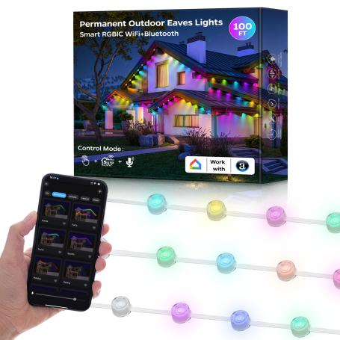

I：Product Parameter:

Product Name | Permanent Outdoor Eaves Light
Light Color | RGBIC-Magic Color
Product Body Color | White / Black
Control Method | APP & Voice Control
Voice Control | Alexa, Google Home, Tmall Genie
Lens Angle | 120 °
Power | 1.8W/LED, 12.6W/Strip ( 12 leds/strip), 129.6W/ Set (72 leds/set)
Connectivity Protocol | 2.4GHz WiFi + Bluetooth
Input Voltage | 100 - 240V
Output Voltage | DC 36V
Specification | One light strip is 5 meters, with 12 leds/ strip, total 6 strips, every led bead can be controlled independently
Operating Temperature | -4℉~ 140℉（-20℃~ 60℃)

10.5cm

2.8cm

Accessories |  |  |  |  |  |  | Name | Specification | Quantity | Remark
 | 2cm | 40cm I |  |  | 3 2cm  . |  | String lights | 36V-5M-12LEDs/Strip Total length: 30M | 6 | Wire length between  two LEDs: 400mm  Length of input &  output wire: 200mm
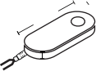  6cm |  |  |  |  |  |  | Controller | 105*60*28mm | 1 | Length of power cable: 295cm
l 12.5cm l |  |  |  |  |  |  | Power adapter | Working voltage：36V | 1 | Plug wire length: 70cm Cable length connected to the controller:195cm
5.6cm
 | 3.7cm
 |  |  |  |  |  |  | Mounting clamp | Length: 33mm width:21mm | 10Pcs
 |  |  |  |  |  |  | Clip | 20.32*27.94inch | 24Pcs
3M |  |  |  | 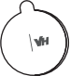  B  TM |  |  | Gum | Diameter：30mm | 12Pcs

Easy to install

1

Clean the surface with a cloth or tissue before installing the string lights.

3

Press the light ﬁrmly against the surface for more than 5 seconds.

2

Tear off the 3M adhesive on the back of the light

4

Connect 2 string lights via the waterproof connectors and screw in the cap.

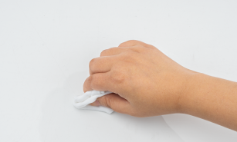
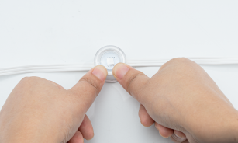
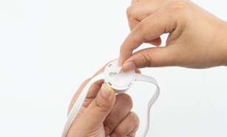
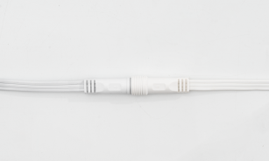

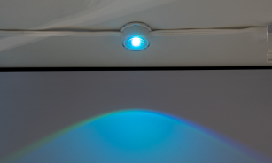
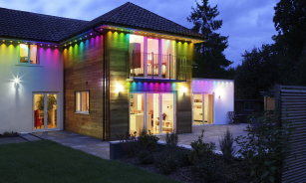
6
5

Please install the string lights 1.91-3.94 Installation completed
inch away from the wall surface.

II ： Wire Connection

LED Strips or other constant voltage lights UFO LED Controller

Power adapter

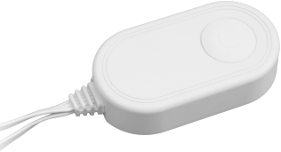

Short press: Turn on or transfer the Built-in modes
Long press: Hold on 3 seconds-turn oﬀ Hold on 8 seconds-restore factory Settings

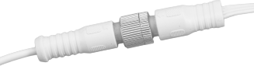

Controller Connector (connects power supply
and controller)

III. Download Surplife APP
Download “Sur plife”APP from Apple Store and Google Play Sto re, or scan the QR code .

Surplife APP



IV. How to connect the controller to Wi-Fi network?
1) Register/Login your Surplife account.

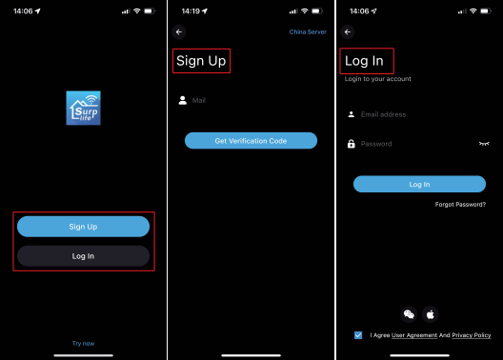

2) Open your phone Bluetooth, turn on the device.

3) Enter “Surplife”app, tap “Add Device”or click “+”to add the device. Then select your Wi-Fi network(Only works with 2.4Ghz network), enter the password .

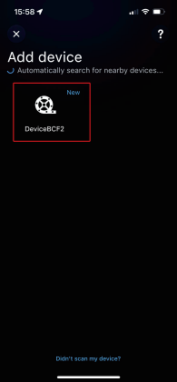
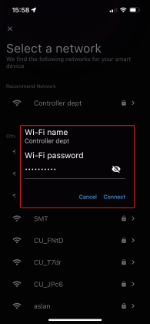
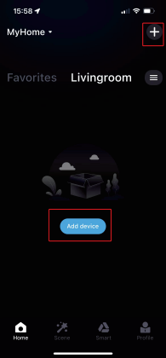

4) The device name can be modiﬁed and select the room after successfully connecting to Wi-Fi network.

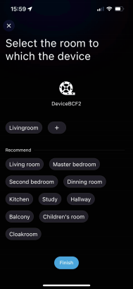
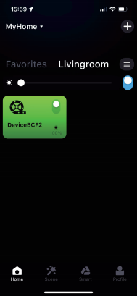
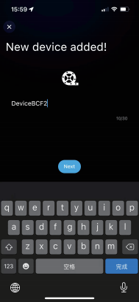

V.About Settings：
1) In the setting interface, you can set the IC model , color correction, number o f points(Total number of points can not exceed 3 00 in each segment and total LE D chips quantity can not exceed 204 8)
2) The setting of IC number is applied to the smearing function

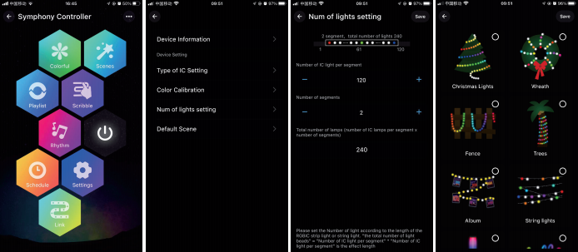
②
①
①

②

VI.Detailed introduction of APP functions：

1) Multi color function
The color of the light can be adjusted by the whole and each segment. App provides different columns for color selection or editing, and the brightness can also be
adjusted. In the segmentation interface, users can freely smear or erase the color of each segment, and also set the gradient effect.

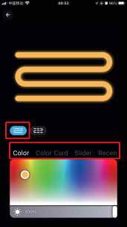
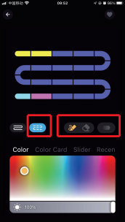

2) Scene settings
T“DeIY”ore“Collection”-ito create:y”oLurfa,voriteligt,eﬀectivals”, “Mood”, and click
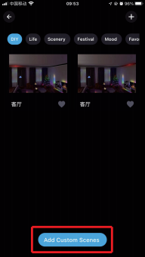
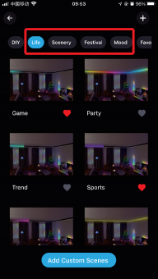

3）Playlist mode
Multiple light dynamic modes built in，can set the time of lighting eﬀects and enter cycle mode.Select diﬀerent scene modes, then set the duration of each scene
respectively, and play it by combining the sequence of diﬀerent lighting eﬀects.

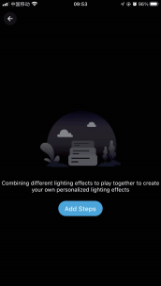
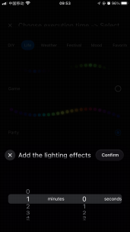
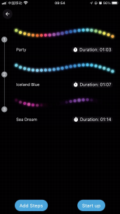
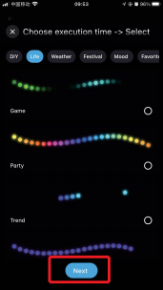

4）Smear function
Click “+”to DIY the lighting color and dynamic eﬀects then save it.
Before DIY, please set the number of IC in "Settings " to ensure that the number of lights is consistent with the device, Otherwise , the lighting eﬀect is incorrect.
Before customize, please ensure that the IC number in app setting is the same as the light device, otherwise, the lighting eﬀect will be incorrect.
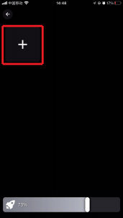
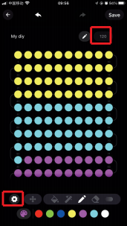
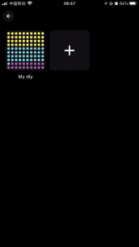
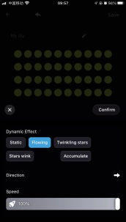

5).Music Mode
1. Synchronization function of lighting and music rhythm.
Click "Add Music" > Import a music ﬁle or import it from the built-in music library.

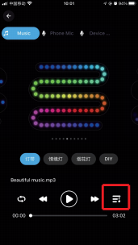
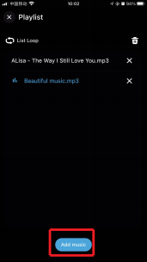

2.MIC
The lights color will change with the sound rhythm when your phone microphone
catches the sound. The microphone sensitivity can be adjusted by the slider.There are two ways to input the audio signal on the controller, built in APP microphone and
external microphone(For sound control version) .

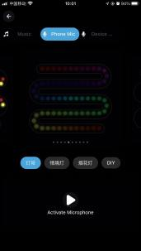
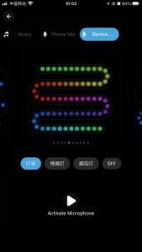

6) Light timer
Smart lights automatically come on andoﬀ at given times through the timer function， choose your favorite eﬀect and color then save it.

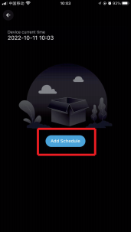
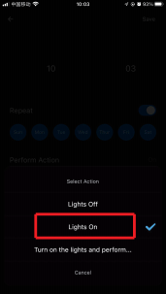
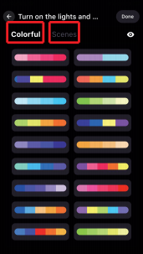
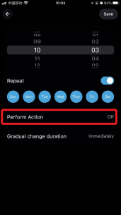

7) Group Control
This mode allows you to create diﬀerent groups to control more than one controllers at the same time.

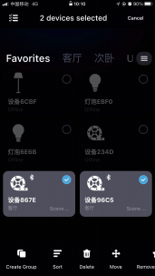
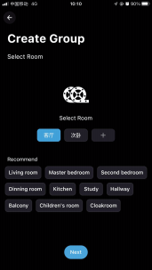

8). Link
Setting a group for the strip lights, enjoy the linkage lighting eﬀect. Hold and drag the device on the list to change the order and the direction.
①The grouped light strips synchronized Linkage
②The grouped light strips change sequentially

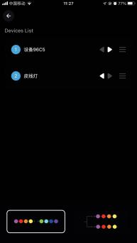

②
①

9) . Apple IOS system widget added (also supports Android phones)
Steps:
1. Create a scene for your light, and add a command for him when you use the widget.

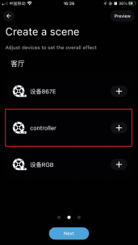
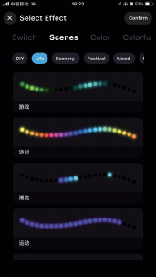
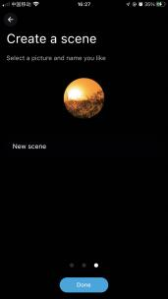
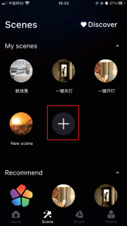

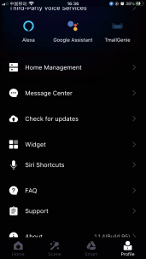
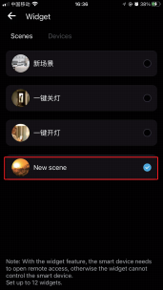
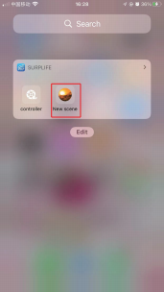
2. Enter the page"Proﬁle" > Tap"Widget" > Add the scene to Widget.Then Add "Surplife" app to Widget

10)Siri Shortcuts-IOS
Note:
1.Siri only can control the scene.
2. IOS 12.0 and above systems have their own shortcut function. 3. Pls make sure your device is "Cloud Online".

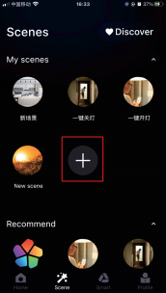
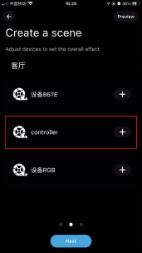

3. Enter the page"Profile" > Tap"Siri Shortcuts" > Add the scene to here.
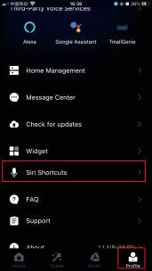
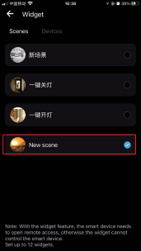

4.Ask Siri: Turn on the {Scene Name}

11) Third-party platform
You can choose the third-party voice service platform (Alexa, Google Home, Tmall Genie, etc.) and bind the platform according to the guidance. After the connection is successful, you can start the voice control, which is convenient and fast.

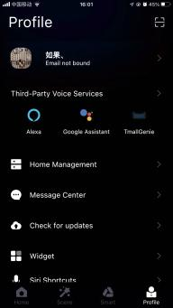
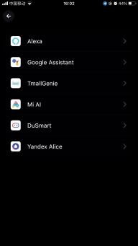

LIAS

Attentions
a）Please use the product in a dry environment.
b）For input voltage, please use the DC voltage within the specified range as instructed in the manual, must not connect into 220VAC directly.
c）The product is requested common anode connection. The wrong connection will cause a malfunction.

